Dear editor Shohji Tsushima:

I have received your letter about the comment for our manuscript “Numerical studies on ejector structure optimization and performance prediction based on a novel pressure drop model for proton exchange membrane fuel cell anode” (HE-D-20-00619). We quite appreciate your favorite consideration and the reviewer’s insightful comments. We have made some revision to our manuscript accordingly and we hope the revision will make our paper more acceptable. All the revisions have been highlighted in the revised manuscript.

Please let me know if you and reviewer have any other questions. Thanks again for your and reviewer’s patience, help and constant attention to our manuscript.

Sincerely yours,

Tiancai Ma

Clean Energy Automotive Engineering Center

Tongji University

**Responses to the reviewers’ comments:**

We highly appreciate the reviewers’ kind consideration of the scientific content of our work. The comments and suggestions made by the reviewers are very helpful for us to revise the manuscript. A detailed reply to the comments and suggestions has been made as follows. (Note: The responses to the reviewers’ comments are highlighted in blue).

**Reviewer: 1**

The paper presents interesting numerical results on anodic recirculation system of a PEM fuel cell. However, they need to improve their analysis and address other points listed below before the manuscript can be published:

Comments:

The authors only mention the benefits of the ejector, while, the ejector should be designed for operation at practical conditions, because a minor deviation from optimal conditions deteriorates the performance, especially when the PEMFC operates in a wide range of load and different operating conditions (Int. J. Hydrogen Energy, 2019, 44, 7518-7530). Also, although an ejector has advantages such as less movable parts, low maintenance cost and relatively high efﬁciency, it involves high noise and high sensitivity to off-design operating conditions (ECS Trans 2007, 5, 773-780; Int. J. Hydrogen Energy 43, 2018 19691-19703).

1. Literature review should be improved by reading and using some important papers for considering anodic recirculation system based on mechanical compressor, ejector, electrochemical pump and etc. in proton exchange membrane fuel cell.

Reply: Thanks for the reviewer’s suggestion. We have improved the literatures survey based on mechanical compressor, ejector, electrochemical pump and etc. in the revised manuscript. The expanded content had been highlighted in the revised manuscript.

2. Authors mentioned "The fluid media is dried nitrogen and the experimental temperature is 18 ℃.", While the operating temperature of the cell is 60-80 ℃. Having different experimental conditions and numerical solutions is no problem for ejector design?

Reply: Thanks for the reviewer’s comments. As mentioned in some literatures, based on the ideal gas assumption and the same turbulence model, it is reasonable to use nitrogen at 18 ℃ to verify the simulation model which was reliable to use hydrogen at higher temperature and humidity (*Appl. Therm. Eng.* **2009**; *29*: 898-905; *Energy Convers. Manag.* **2016**; *126*: 1106-1117; *J. Power Sources* **2019**; *415*, 25-32.). Thus, in this work, we used the nitrogen at 18 ℃ in the verification experiment and used the same temperature and humidity as the operating conditions of the PEMFC in the model to simulate the performance of the ejector.

3. See attached file: figure 1.

Reply: Thanks for the reviewer’s advice, and we have revised some mistakes in the Figure 1. The revisions had been highlighted in the revised manuscript.

4 Why the SST k-<omega> turbulent is used to model the turbulent flow. Why this model is more accurate. Many papers have shown that Realizable k-<epsilon> turbulent model is better to model the ejector.

Reply: Thanks for the reviewer’s reminding. In the ejector simulation, no turbulence model has an established position. And in this work, we tend to focus on the performance prediction of ejectors. The SST k-<omega> model is more useful for predicting ejector performance while the Realizable k-<epsilon> turbulent model should be adopted when optimizing ejector design (*Int. J. Hydrogen Energy* **2016***; 41:* 14952-14970*.*). Thus, we choose the SST k-<omega> turbulent model.

5. Authors mentioned "The pressure drop for PEMFC stack anode has a strong relationship with the design and the working performance of the ejector", While the pressure drop in the fuel cell depends on the pattern of the flow channels and manifolds.

Reply: Thanks for the reviewer’s suggestion. Due to the inaccuracy of our expression, some misunderstandings have been caused to reviewers. Thus, we rewrite this sentence to “The pressure drop of PEMFC stack anode is a significant factor which can influence the design and the working performance of the ejector.” The revisions had been highlighted in the revised manuscript.

**Reviewer: 2**

The authors carried out numerical study to optimize an ejector used for hydrogen circulation for 100kW PEMFC stack and investigated performance of the ejector. Less novelty is found on numerical simulation procedure using ANSYS FLUENT. The following concerns arise:

1. The authors performed experiments to validate their simulations, but nitrogen was used. Please comment on any temperature change of fluid after being injected as well as thermal boundary condition in both experiments and simulations.

Reply: Thanks for the reviewer’s suggestion. In our experiment, the fluid temperature was considered the same as the environment of 18 ℃. According to the high speed of gas inside the ejector, the ejection process was assumed as an isenthalpic process and the fluid was assumed as ideal gas in the simulation. (*Appl. Energy* **2019**; *235*: 729-738.) So in the simulation, the Joule-Thomson effect was not considered. Meanwhile, the reviewer’s comment reminded us of the possible temperature changes in the fluid. So we have carried out the test with the temperature sensors at the upstream of the primary inlet, and the downstream of the ejector outlet. The temperature of the fluid at the outlet of the ejector was just 1 ℃ lower than the primary inlet of the ejector. And the temperature difference was supposed to be generated from the sensor error and pipes. More researches need to be expanded in our future work to study the possible temperature change at the boundaries of the ejector. We have revised our manuscript according to the reviewer’s comment on the thermal boundary condition in both experiments and simulations as follows:

2 Experimental

To verify the correctness of the simulation model, an ejector test platform is established to test the ejector. Figure 1a exhibited the schematic diagram of the ejector test platform. The fluid media is dried nitrogen and the fluid temperature is assumed the same as the experimental temperature of 18 ℃. During the test, the mass flow is regulated by the needle valve to simulate the hydrogen consumption of the PEMFCs. The pressure data is feedback to the proportional valve by the pressure sensor (P6) to control the inlet pressure and the flow resistance of the stack is simulated by the ball valve. The solenoid valve can be used to simulate the exhaust process of the anodic recirculation but is closed here. The primary flow and secondary flow are measured by flowmeter 1 and flowmeter 2, respectively.

3.2 Boundary conditions

The ejector model boundary conditions are correlated to the working conditions of PEMFC. As the ejector primary inlet flow rate is corresponding to the PEMFC stack working current, the inlet of the primary flow adopts the boundary conditions of the mass inlet. The outlet of the ejector is set as a pressure outlet where the static pressure equals to the PEMFC stack inlet pressure. Since the upstream pressure of the porous jump boundary is considered as the PEMFC stack inlet pressure, the second inlet is a pressure inlet as well with the same parameters as the ejector outlet. According to the high speed of gas inside the ejector, the ejection process is assumed as an isenthalpic process, and no heat conduction is considered through the walls. The fluid media is assumed as ideal gas.

2. Please cite the literature to refer an pressure drop data in Fig.2.

Reply: Thanks for the reviewer’s comment. I'm very sorry that the inaccuracy of our expression caused the misunderstanding of reviewers. The data in figure 2 comes from the test of our own fuel cell stack. Thus, the sentence has been revised and the revisions had been highlighted in the revised manuscript.

3. How can the authors conclude that this parameter set in table 3 is the best one. All six design parameters should be optimized together.

Reply: Thanks for the reviewer’s comment. It is our mistake that the sensitivity analysis of the ejector parameters is not fully explained in our manuscript. As shown in Figure 5, we have proved the sensitive between nozzle exit diameter (D1) and mixing tube diameter (D2). Due to the pressure limit by the working pressure differential range of the proportional valve upstream of the ejector and the pressure fluctuation, the D1 was set as 2 mm. After that, the optimization value of the D2 was 10.5 mm.

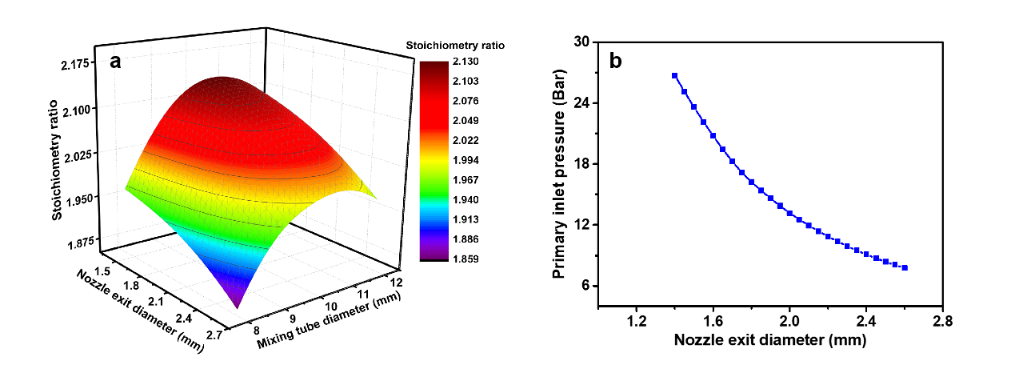

**Figure R1** (a) The relationship between D1 and D2 of the ejector (Primary flow rate is 1652 SLPM), (b) The relationship between D1 and the primary inlet pressure of ejector (The primary flow rate is 1652 SLPM).

Then, we compared the sensitive between D2 and the nozzle exit position (L1), the mixing tube length (L2), diffuser length (L3), diffuser divergence angle (A2). As shown in Figure R2, the other four design parameters have little influence in the stoichiometry compared with the mixing tube diameter. So, in order to simplify the optimization process, we optimized these four design parameters in two groups and we could get the optimal parameter more easily. Finally, the relative optimal ejector parameters are obtained.

Meanwhile, this part is added in the manuscript and the revisions had been highlighted in the revised manuscript.

E:\同济博后\论文\引射器\Figure\Figure 15.tif

**Figure R2** The relationship between D2 and (a) L1, (b) L2, (c) L3, (d) A2 of the ejector (Primary flow rate is 1652 SLPM).

Additionally, your literature survey needs improvement; please expand it. Additional related papers can be found in the International Journal of Hydrogen Energy (IJHE), as well as in other energy and fuel cells related publications.

Reply: Thanks for the editor’s advice. We have expanded the literature survey in the revised manuscript. The expanded content has been highlighted in the revised manuscript. Moreover, we find some inaccuracy expression in the manuscript. We have revised them and the revisions had been highlighted in the revised manuscript.